Table 01: Test of “*Parallel Trends”* assumption for the Difference-in-difference (DID) estimate:

|  |  |
| --- | --- |
| *OLS* | Lung Hospitalizations |
| *Treated States* | -2,515*** |
|  | (261.4) |
| Constant | 114,268*** |
|  | (177.3) |
| *Year Fixed Effects* | 20 |
| *Year X Treatment Effects* | 20 |
| Observations | 1,050 |
| R-squared | 0.884 |
| Standard errors in parentheses |  |
| *** p<0.01, ** p<0.05, * p<0.1. |  |

Notes:

1. On average, there are about 2515 units of decrease in lung hospitalizations if vaping bans increase by one unit. The specification involves year and year X treated fixed effects. The result is significant at 15 level.
2. Coefficients for year and year X treatment FE are in “results01.xls” in the GitHub repository.
3. The marginal effects from this regression are obtained to plot the *trends* graph below.

Figure 01: Visual representation of the *parallel trend* assumption (Obtained from Marginal effects from Table 01):

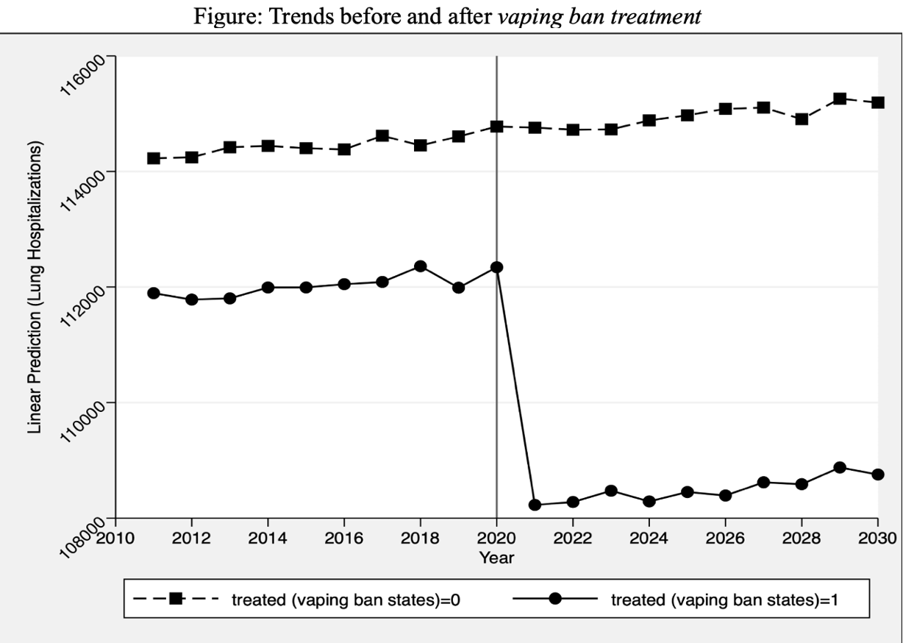

Table 02: Table for Difference-In-Difference Estimates

|  |  |
| --- | --- |
|  |  |
| OLS | Lung Hospitalizations |
| *Treated (vaping ban states)* | -4,918*** |
|  | (139.3) |
| *Post (2021 and after)* | 974.6*** |
|  | (110.5) |
| *Treated X post* | -4,030*** |
|  | (65.60) |
| Constant | 115,705*** |
|  | (117.7) |
| Year Fixed Effects | Yes |
| State Fixed Effects | Yes |
| Observations | 1,050 |
| R-squared | 0.963 |
| Robust standard errors in parentheses |  |
| *** p<0.01, ** p<0.05, * p<0.1 |  |

Notes:

1. The Average Treatment Effects on the Treated (ATET) is -4030. This is the average treatment effect on the states that banned vaping devices, the number of lung hospitalization is predicted to decrease by 4020 in states that banned vaping compared to states that did not.

2. Year and State fixed effects are included in the model to control for state and year generated heterogeneities.

3. The model includes 49 states and 19-year fixed effects, one year and state being the left-out ones.

Questions:

1. How many state-level fixed effects are there?

* There are 49 state level fixed effects in the DID model (Table 02). State 1 being the left-out category.

1. What is the interpretation of the coefficient for each state-level fixed effect?

* All the control group States 24-49 have negative coefficients (statistically significant).
* All treatment group States 2-23 have positive coefficients (all statistically significant, excepting 2 and 3)

Note:

1. Testparm results of state fixed effects shows 0 for all the states with F statistic of 43.71(*p-value: 0.000)*